**MODULE I**

**FUNDAMENTALS OF E-COMMERCE**

1. **THE ORIGIN AND DEVELOPMENT OF E-COMMERCE**

**E**-**commerce** (electronic **commerce** or EC) is the buying and selling of goods and services, or the transmitting of funds or data, over an electronic network, primarily the internet.

Internet has created a new world beyond the real world—a “virtual network world” or “The sixth continent”. E-commerce brought about by Internet is one of the most significant scientific accomplishments. In business, the prosperous e-commerce technology gives rise to a revolution in the circulation system. It breaks the boundary of time and space, alters the trade pattern, improves the circulation of merchandize, capital and information, and makes enterprises have an edge over others as well by reducing the cost of production effectively. In short,e-commerce has enabled the traditional business to achieve greater, faster, better and more economical results.

E-commerce is the necessity of international business, vice verse, international business boosts e-commerce. The development of computer science and communications sciences has laid a solid foundation for e-commerce. The development of information security makes e-commerce proceed in a secure way.

**The development of e-commerce**



It is based on 3 phases.

* **Phase One**: E-commerce based on EDI (Electronic Data Interchange)
* **Phase Two:** E-commerce based on Internet
* **Phase Three:** E-concept based E-commerce

**Phase One: E-commerce based on EDI**

EDI is a kind of teleportation method to transmit business documentsfrom one computer to another. EDI reduces the paper note greatly, people vividly call it as “trade without paper” or “bargain without paper”. EDI includes both hardware (mainly the network) and software (mainly software and standard of EDI).

EDI needs is a standard software to translate information in the customer databases into the EDI-standard so as to deliver. Because the business enterprise of different professions adopt different format on the basis of their own business characteristics, therefore when transmitting documents, they must be translated into the EDI standard format.

**Phase Two: E-commerce based on Internet**

EDI speeds up the development of international business. However, the high cost of VAN and EDI communication system hinder the expansion of e-commerce based on EDI. Moreover, EDI is only suitable for large-scaled transnational corporation rather than medium and small-sized ones.

Business that has always been outside of Internet came into the realm and made e-commerce a big hit in Internet. Many enterprises made a big success by online direct marketing such as Dell Company, distinguished for direct online selling, online book store Amazon, Yahoo Internet search engine, Baidu Internet search engine, Sina, Sohu, and Ebay.

**Phase Three: E-concept e-commerce**

1. concept e-commerce, and it is realized that e-commerce is in fact the combination of information technology and commerce applications.Electronic information technology can be applied in many other fields,such as medical treatment, education, hygiene, military, administration and so on,to form e-concept in the fields. For instance, electronic education—remote education, the combination of electronic information technology and education;electronic treatment—remote treatment, the combination of technology and treatment;electronic administration, the combination of technology and administration;electronic command, the combination of technology and command; online banks,the combination of technology and finance; virtual enterprises, the combination of technology and business organizations and so forth. Various patterns of e-commerce such as E-B, E-C, E-G etc., have come into being by applying e-conept. With the development of electronic information technology and the increasing need of the society, more and more e-concepts will emerge and the genuine e-times will advene

**2.DEFINITION OF E-COMMERCE**

E-commerce refers to various online commercial activities focusing on commodity exchanges by electronic means.

**ISO** defines e-commerce as: it is the general term for exchange of information among enterprise and between enterprise and customers.

**Global Information Infrastructure Committee** defines it as the economical activities using electrical communications, with which people can purchase products, advertise goods and settle.

**Intel:** E-commerce=electronic market+electronic trade+electronic service

**IBM:** E-commerce=information technology+web+business

**HP:** E-commerce is to accomplish commercial business by electronic means.

E-commerce shall be social, economic activities between social principal parts by taking advantages of computers and network.It refers to commercial trade activities carried out by electronic methods, the electronicization of traditional trades.

E-commerce refers to various online commercial activities focusing on commodity exchanges by electronic methods.

Electronic business (EB) refers to the electronicization of all business among all industries.(including governments,enterprises, and institutional units), such as electronic government, electronic command, electronic education, electronic public business, electronic household etc.Components of e-commerce are,

1. Network

(2) E-commerce user

(3) Authentication Authority

(4) Distribution center

(5) Online bank

(6) The administration of the commercial activity



1. **Network:**

It includes Internet, Intranet, and Extranet. Internet is the foundation of e-commerce and the carrier of commercial business information. As to Intranet,it means for enterprises to carry out internal affairs. With regard to Extranet, it is the link between enterprises and users to carry out commercial activities.

1. **E-commerce user.**

It includes personal consumers and business consumers.The business consumer scientifically manages staff, wealth, goods, production,supply and sales by Intranet, Extranet and MIS. Personal consumer has access to information and purchases goods by connecting Internet with browsers, set-top boxes, PDA (the personal digital assistance), Visual TV etc.

1. **Authentication Authority:**

The authentication Authority (CA), the authority recognized by law, is responsible for issuing, managing digital certificates and facilitating parties involved in online sales to identify each other.

1. **Distribution center:**

It is in charge of sending goods that cannot be delivered on line to consumers and keeping track of goods flow.

1. **Online bank:**

It provides the sellers and buyers the traditional bank business,such as settlement, and round-the-clock service.

1. **The administration of the commercial activity:**

It consists mainly of departments of industry, customs, tax and trade.

**The Significance of e-concept**

**Email:**

* E-mail, called the Internet Killer User, attracts people to pay attention to the existence of the network, and sparks the rush of network gradually.
* E-mail transforms from receiving and sending e-mails to commercial use and becomes one of the principal tools for people to communicate on line.

**E-wallet and e-cash**

* Basically make it possible for people transfer fund on line and accordingly makes network and real life fuse further.
* The e-commerce has on a large scale began to impact the traditional pattern of trade and brought about intense changes of life style.

**3.IMPACT OF COMPUTER SCIENCE UPON THE E-COMMERCE**

E-commerce is based on electronic information technology, in which information storage, information exchange and information processing are all carried out by computers and Internet.

Since the birth of the first computer with vacuum tubes, electronic devices have gone through the following steps: vacuum-tube circuit, transistor circuit, integrated circuit, large scale integrated circuit (LSI) and very large scale integrated circuit (VLS1).

With the improvement of electronic device manufacturing technology, there emerge minicomputers, large computers and parallel computers. The computer technology, the core of information technology,has gradually become mature after the development of half a century.

TCP (Transfer Control Protocol) / IP (Internet Protocol) translates the traditional network into the universal computer network.

VPN (Virtual Private Network),Gigabyte Ethernet wiring system and modem, shape and urge the development of e-commerce.

The universality of TCP / IP greatly facilitates the transmission of information between the networks conveniently, lowers the cost of information acquisition;the emergence of routing technology and the continuous creative innovation of the routing algorithms,

The rapid development of the intranet and extranet,based on IP, has turned into the foundation for enterprises to carry out e-commerce.The emergence of WWW technology leads to the boost in Internet users and makes online information more abundant, colorful, multimedialized and easy to accept. The wireless communication is heading for datamation and high bandwidth.

It is the telecommunication that enables the rapid development of a series of long-distance applications, such as so called distance education and distance medical treatment etc.

Computer languages have developed, from machine language, to assembly language, advanced language and even to the intelligence language, and many operating system softwares.

The key factor to ensure the popularity of e-commerce is the security of information, for which various encryption technologies such as symmetric key encryption and public key encryption are developed to provide the basis of information privacy. In addition, technology's of firewall and intrusion detection keep information from being destroyed and stolen illegally.

**4.IMPACT OF COMMUNICATIONS SCIENCE UPON THE E-COMMERCE**

In e-commerce, communication system is the carrier of information flow and capital flow, and exchanges and transmission of information are both carried out through communication network consisting of transmission, switch, terminal equipment, signaling, protocol and corresponding operation support systems**.**

Itis necessary to build up wide communication channels for information transmission and exchange of e-commerce network.

The rapid development of contemporary communication technologies laid the foundation of e-commerce.

The birth of digital computerized telephone switching technology lays the foundation for modern digital communication technology.

The maturity of optical communication technology, especially the rapid development of the wavelength division multiplex (WDM, for short) promotes the sharp rise of bandwidth of principal networks and provides the guarantee for the extension of network and the smooth transmission of the expanding information.

The progress of wireless communication technologies such as mobile technology and satellite communication technology supplies the new way to achieve the universal overlaying and flexible application of information network and lays the foundation for the extension of e-commerce to wireless application fields.

Telecommunication network is the key to informatization.

The combination of computer network and communication network,enormous computers can simultaneously process texts, data, images and voice etc.

The mobile communication (the information transmission process in which both parties or at least one party involved carry out information exchange while moving) is the determining technology for information exchange, usage, processing, and releasing between any communication subjects all over the world anytime and anyplace and the core technology to realize Mobile-commerce.

Internet is the technical foundation and indispensable for e-commerce. The development of e-commerce will definitely make greater demands on the communication technology and boost the development of communication technologies; the development of communication technologies provides technical support for new applications of e-commerce.

#### 4.IMPACT OF COMMUNICATIONS SCIENCE UPON THE E-COMMERCE

In e-commerce, communication system is the carrier of information flow and capital flow, and exchanges and transmission of information are both carried out through communication network consisting of transmission, switch, terminal equipments, signaling, protocol and corresponding operation support systems. It is necessary to build up wide communication channels for information transmission and exchange of e-commerce network. The rapid development of contemporary communication technologies laid the foundation of e-commerce vomitorium.

The birth of digital computerized telephone switching technology lays the foundation for modern digital communication technology.

The maturity of optical communication technology, especially the rapid development of the wavelength division multiplex (WDM, for short) promotes the sharp rise of bandwidth of principal networks and provides the guarantee for the extension of network and the smooth transmission of the expanding information.

The progress of wireless communication technologies such as mobile technology and satellite communication technology supplies the new way to achieve the universal overlaying and flexible application of information network and lays the foundation for the extension of e-commerce to wireless application fields.

Telecommunication network is the key to informatization. It is the presence of data information network that extends communication coverage promotes communication to enter into the service stage and leads to the birth of such business based on public data network as e-mails, e-data interchange, e-numbering book, e-bulletin board system and e-commerce.

The combination of computer network and communication network, enormous computers can simultaneously process texts, data, images and voice etc. The above information can be available everywhere and exchanged within China or the world.

The development of e-commerce demands for higher and higher communication. Safe, high-speed network transmission and multimedia communication have been the inevitable factors to carry out e-commerce.

The mobile communication (the information transmission process in which both parties or at least one party involved carry out information exchange while moving) is the determining technology for information exchange, usage, processing, and releasing between any communication subjects all over the world anytime and anyplace and the core technology to realize Mobile-commerce.

Internet is the technical foundation and indispensable for e-commerce. The development of e-commerce will definitely make greater demands on the communication technology and boost the development of communication technologies.

**5. THE IMPACT OF MANAGEMENT SCIENCE UPON E-COMMERCE**

The focus of management is to raise labor productivity by managing equipments and staff manually with strict regulations.

The main task of governors is to increase labor productivity and supply. In the behavior management phase, the focus of governors is to transform the volume-produce mode into small-lot versatile production mode.

The customers began to push forward their claims for high-quality products. Products of low-quality are difficult to sell.

The main task of the administrator is to sell out their commodity, commodity of high-quality, small lot and diverse types should be manufactured to satisfy various requirements of customers,they have began to make and carry out decisions dynamically, continuously and adapt themselves quickly to changing internal and external conditions to balance stability, continuity, suitability, and innovation.

Enterprises try to regroup operation flow is the effective path for enterprise to regain competitive power.

The implementation of Business Process Reengineering (BPR, for short) needs two foundations, that is, modern information technology and high-caliber talents.

The need of information processing facilitates the extension of computers in enterprises and the rapid development and popularity of management information system (MIS, for short) and decision support system (DSS, for short), thus accelerating the rapid development of computer hardware and software, computer information processing technology and message-switching technology as well as setting up the foundation for the development of e-commerce.

In the organizational management phase of globalization and knowledge economy age, the waves of informatization and globalization spread all over the world rapidly. Because of the arrival of the knowledge economy, information and knowledge become significant strategic resources.

**6. THE CONSTITUTION OF THE E-COMMERCE**

#### i. Portal of the Network

Portal websites are applications systems that lead to some comprehensive Internet information sources and provide relevant information services.

At the beginning, the portal websites offered search engine and the network access service. Later, it had to expand a variety of new services in the hope that Internet users would be attracted and maintained by the business of different kinds, which causes a wide variety of services to come up in different portal websites currently, making the network a “department store” or “network supermarket”.

The portal websites mainly provide such services as news, search engine, online access, chat room, e-board, free mailbox, movies and music information,

e-commerce, online community, online game, free space in website, etc.

The typical examples are www.sina.com, www.163.com, www.sohu.com, etc in China,Amazon as business portal.

The portal websites evolves as is shown in Figure.

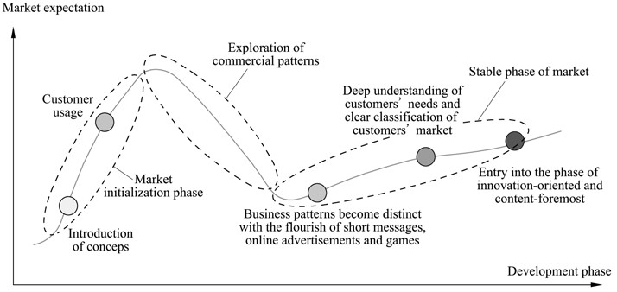

#### ii.Customer Relationship Management

Customer relationship management (CRM for short) is a new research filed of management which devolved rapidly to adapt to the strategic transfer from product-centered management to costumer-centered one. It considers satisfaction and loyalty of customers as the final goal.

CRM has to rest on two solid foundations: reasonable organization structure and reasonable information structure.

##### Client Intelligence (CI)

It is the process of gathering and analyzing information regarding customers,their details & activities to build deeper and more effective customer relationships.

Some specialists mentioned the notion of client intelligence in research. They classified it into three categories: the first one is the research on function, contents and essence of client intelligence.

Client intelligence system comprises the following levels:

1. Theoretical foundation

The theoretical foundation of client intelligence is guidance for enterprises to make decisions about clients. It includes not only the theories and measures by which enterprises analyze and treat clients, but client value analysis from the perspective of clients and enterprises respectively.

(2) Information system

It is the physical foundation for CI system, and is reflection in software which has strong capacity to make decision and analysis and in information system platform gearing to the special application field.

(3) Data analysis

As a series of computation, devices or models, it intends to obtain high-quality data or information about the theme concerned, then involve in using analytical computation, devices or models automatically or by hand to help people analyse information, reach a conclusion, form a hypothesis and test a hypothesis.

1. Knowledge discovery

It is a series of computation, tools or models. It intends to transform data into information, then into knowledge through discovery, or directly transform data into knowledge.

1. Strategic level

It intends to apply information or knowledge to such aspects as improving decision-making, operational capacity, enterprises’ construction model, etc. The strategic level is a combination of a series of concepts, methods and processes for improving the enterprises’ capacity to make decisions by use of information from many sources and application experience and hypothesis.

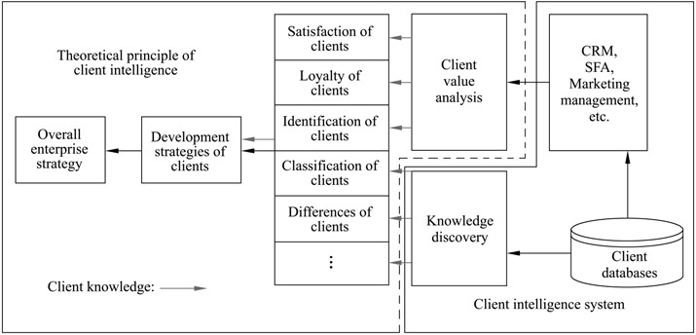

iii.Supply Chain Management

The supply chain is a functional net-link model integrated by suppliers, manufacturers, distributors, retailers and final users, a net-link model that, under the control of information, logistics and fund flow control, that start with procurement of raw materials, makes the intermediate products and final products, and then delivers the products to the consumers through the sales network.

Supply chain management (SCM for short) is an idea and method of integrated management, and performs functions like logistics plan and control from supplier to final users in the supply chain.

##### 1. SCM Pattern

Enterprise integration is the core of SCM, which has two chief types as shown in Fig. push and pull.

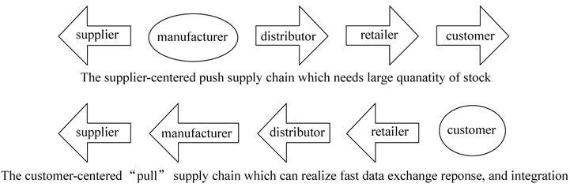

**Figure:** Change of supply chain from push pattern to pull pattern

In pull type, consumers are on the front of SC, also called demand-driven type. When client check on the counter,it will record the details of each purchase; distribution center will add goods to shops according to record; after the data of each delivery center is gathered at the manufacture’s office, manufactures will then accordingly add goods to distribution centers; the manufacture’s production program will update according to distribution arrangement and also will adjust the procurement arrangement. Finally, suppliers of raw materials will also change the distribution plan.

Compared to push type, pull type boasts the following advantages:

* support the continuous changes in products ĸ shorten the time period for delivery
* improve the service for clients, with the cost per unit down
* improve the efficiency in business
* be able to give an overall assessment on performance, which makes it much easier to control

##### 2. Functions of SCM

There are mainly the following 4 functions:

i.Client relation management: fully understand and predict market and users’ demands by managing the information of client’s demands. By using client service, supporting sales or other functional systems, enterprises gather information, and collect the information gathered from the real business in order to pre-control.

ii.Comprehensive logistics management: to manage the logistic work including production plan, procurement and stock from suppliers to clients.

iii.Production process management: to manage the whole process of production, reducing production cost while raising the efficiency.

iv.Accounting management: to co-manage fund flow with suppliers and clients by use of network accounting management system.

##### 3. Components of SCM

Implementation of SCM system includes 3 processes: planning, implementing and assessing performance. Among these processes, client’s demands must be taken into account. At the same time, enterprises must perfect interior process, and transfer the traditional function-oriented viewpoint to process-oriented viewpoints.

1. Plan system-It refers to obtaining the right products in the right place at the right time.
2. Implementation system-The implementation system promotes the movement of products including performance of client’s orders, procurement, stock control, production and logistics systems.
3. Performance assessment system-It mainly comprises accounting system and financial management system.

**4. Logistic Management**

The logistics refers to the unified arrangement of the goods production, procurement, transport, delivery during the war to seek better service, faster speed and lower cost in terms of the supplies for war.

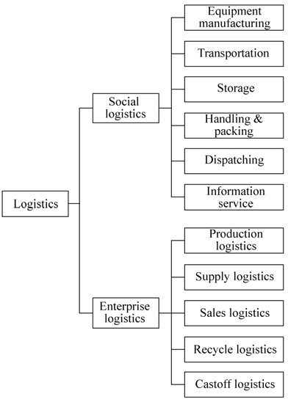

#### 5. Decision Support

The key for management is decision-making. The economic globalization and development of information technology eliminates many barriers. The enterprises are facing more complex environment than ever, and it is much harder to form and maintain their competition barriers. The pressure from competition raises higher standard for the quality and speed of making decision.

A DSS comprises of the following typical components:

1. Database management subsystem
2. Model management sub system
3. Knowledge management subsystem
4. User interface subsystem
5. Users
6. **AUCTIONS**

It is the sale of goods/property to bidders.It support dynamic foundation of prices.

User sell/bid for products/services using Internet.

The online environment is particularly conducive to auctions, due to at least two

important properties of the electronic medium.

1. The network supports inexpensive, wide-area, dynamic communication. Although the primitive communication protocol is point-to-point, a mediating server (i.e., the auction) can easily manage a protocol involving thousands of participants.
2. Auction-mediated negotiation is tedious, it can be automated. Not only the auctioneer, but also the participating traders, may be represented by computational processes.For example, many sellers employ listing software tools to post large collections of goods for sale over time. To date, trading automation appears to be only minimally exploited by buyers in popular Internet auctions, for example, via “sniping” services that submit bids automatically at designated times, thus freeing the bidder from the necessity of manual monitoring.

**AUCTION TYPES**

*1)****Open outcry auction*s**, which share the property that all status information (e.g., the tentative prices) is conveyed immediately and globally to all participants.Another form of open outcry auction is the familiar “trading pit” of a commodities or securities exchange.

The most immediately distinguishing feature of the trading pit is that it is *two-sided*: both buyers and sellers play bidders in this protocol. In contrast, the art, livestock, and fish auctions alluded to above are *one-sided*: a single seller offers an item to multiple bidding buyers.

2)The ***inverse one-sided auction***—where a single buyer receives bids from multiple competing sellers—is sometimes called a *reverse auction*, and is often employed by businesses in procurement, where it is often called a *request for quotations*, or RFQ

3)***Sealed-bid auctions*** the participants do not learn the status of the auction until the end, if then, or until some other explicit action by the auctioneer. Familiar examples of sealed-bid auctions include government sales of leases for offshore oil drilling and procedures by which real-estate developers let construction contracts.Sealed-bid auctions may also come in one-sided or two-sided varieties.Participants do not learn status of auction till end.

All bidders submit sealed bids to auctioners,They do not know bid of other participants.

**8)Electronic Data Interchange** (**EDI**)

EDI is the electronic interchange of business information using a standardized format; a process which allows one company to send information to another company electronically rather than with paper. Business entities conducting business electronically are called trading partners. It is used in Warehousing utilities,Manufacturing,Shipping,,Pharmaceuticals,Construction,Petroleum,Metals,Banking,InsurANCE,Health care,textiles etc.

Benefits

1.Improvement in overall quality

2.Reduced Inventory

3.Better information for mangement decision making

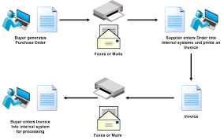

## The Need for EDI

For companies of any size, implementing EDI is necessary for maximum competitiveness and growth. It reduces costs and improves operational performance across your organization. From the start, EDI accelerates data exchange and sharpens accuracy. Your company and your customers benefit from streamlined administration, improved information flow, more accurate accounting, better **inventory management**, and lower costs. Because electronic transactions are so efficient, customers that use EDI prefer to work with vendors that have EDI systems in place.  
From financial, operational, and technical perspectives, the right EDI solution makes irrefutable business sense.

## Necessary EDI components

A complete system for exchanging electronic transactions consists of four elements, preferably in an end-to-end solution from a single vendor.

* [Web-based EDI](https://www.truecommerce.com/solutions/truecommerce-platform/web-based-edi) tool that translates your accounting information into the EDI format
* EDI mapping syncs your accounting system to your customer’s system
* Transaction network sends and receives transactions
* Ongoing [EDI support](https://www.truecommerce.com/how-we-help/truecommerce-edi-platform/support-services) and maintenance services